Computer Programming  
Lab Tasks



Department of Computer Science - BUIC

Name: Saad Ahmad

Enrollment Number: 01-134222-130

**Exercises/Lab Journal13**

**Task 1:** Write a complete C++ program with the following features.

1. Declare a structure Point with two integer members x and y.
2. Define a function getInput(),which accepts a Point by reference. Get user input for a Point in this function.
3. Define a function addPoints()**,** which accepts two Points p1 and p2. The function adds their respective members, and returns a Point which is the sum of two. For example if one point is (2,3), the other is (4,5), the function should return a Point (6,8).
4. In the main(), declare two variables of type Point. Call the function getInput() twice to get the values of these Points from user. Add the two Points using the function addPoints() and display the x and y values of the result returned by the function.

**Code:**

#include <iostream>

using namespace std;

struct Point {

int x;

int y;

};

int getInput(Point &p) {

cout << "Enter point 1:" << endl;

cin >> p.x;

cout << "Enter point 2:" << endl;

cin >> p.y;

return 0;

}

int addPoints(Point p1, Point p2 , int &x ,int &y) {

int a = p1.x + p2.x;

int b = p1.y + p2.y;

x = a;

y = b;

return 0;

}

int main()

{

Point p1, p2;

int x, y;

getInput(p1);

getInput(p2);

addPoints(p1, p2 ,x,y);

cout << x << " "<< y;

return 0;

}

**Output:**

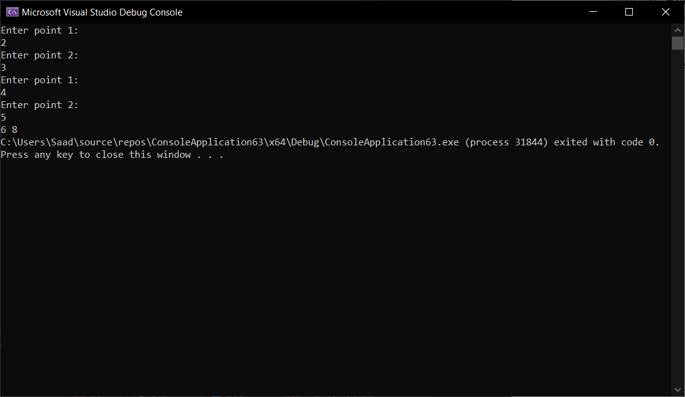

**Task 2:**

* 1. Declare a structure Rectangle with two Points as its members, the top left and the bottom right.
  2. Declare a variable of type Rectangle and get user input for the two points.
  3. Define a function computeArea() which accepts a Rectangle and returns its area.
  4. Display the area of the Rectangle in the main().

**Code:**

#include <iostream>

using namespace std;

struct Rectangle {

int t_left;

int b_right;

}in;

int computeArea(Rectangle a) {

int b = a.t_left * a.b_right;

return b;

}

int main()

{

cout << "Enter an integer" << endl;

cin >> in.t_left;

cout << "Enter an integer" << endl;

cin >> in.b_right;

cout << "The area of the rectangle is : " << computeArea(in);

return 0;

}

Output:

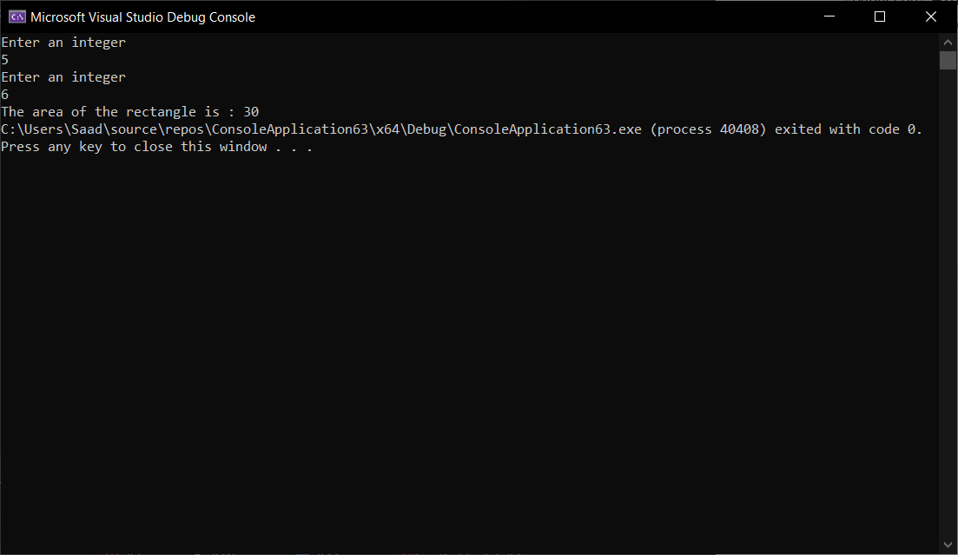

**Task 3 (Optional):**

* 1. Declare a structure Time with fields hours and minutes.
  2. Declare another structure Flight with fields to store flight ID, arrival time and departure time.
  3. Define a function input(Flight *) which allows users enter data for a flight.
  4. Define another function display(Flight *) which displays the data for a flight.
  5. In the main, declare a variable of type Flight and call the input() and display() functions.

#include <iostream>

using namespace std;

struct Time {

int hours;

int minutes;

};

struct Flight {

int f_ID;

int arr_time;

int dep_time;

};

int input(Flight &b) {

cout << "Enter flight ID : " << endl;

cin >> b.f_ID;

cout << "Enter arrival time : " << endl;

cin >> b.arr_time;

cout << "Enter departure time : " << endl;

cin >> b.dep_time;

return 0;

}

int display(Flight b) {

cout << "Flight ID :" << endl;

cout << b.f_ID << endl;

cout << "Arrival Time : " << endl;

cout << b.arr_time << endl;

cout << "Departure Time" << endl;

cout << b.dep_time << endl;

return 0;

}

int main()

{

Flight a;

input(a);

display(a);

return 0;

}

